

**UNIVERSITY OF PETROLEUM AND ENERGY STUDIES**

**School of Computer** **Science**

**2020-21**

**GRAPHICS AND ANIMATION TOOLS LAB**

**Faculty: Dr. DURGANSH SHARMA**

**Assistant Professor**

**Department of Cybernetics.**

**School of Computer Science, UPES**

**Submitted By:**

**Name- Ishita J Karmakar**

**Roll no-R100217107**

**Batch-B3**

**Semester- 7**

**Course-B.Tech CSE-OSOS**

**SAP ID- 500064067**

**EXPERIMENT NO 9**

**Aim** :- Design a 3D Mountains using Blender.

**Objective** :- To Design a 3D Mountains using features of Blender 2.8.

**STEPS TO DESIGN A 3D MOUNTAIN-**

1. Open Blender workspace select the existing cube and delete it.
2. Go to Edit Menu and select ‘Preferences’ option. Select Add-ons in the appeared dialogue box, then tick the ‘Add-Mesh-Landscape’ option.
3. Now to Add, and then add Landscape.
4. In the Add Landscape dialogue box, change the settings as per preference in order to make the mountain more realistic.
5. Add another landscape, to add more scenic beauty. Repeat the Step 4 for this landscape too.

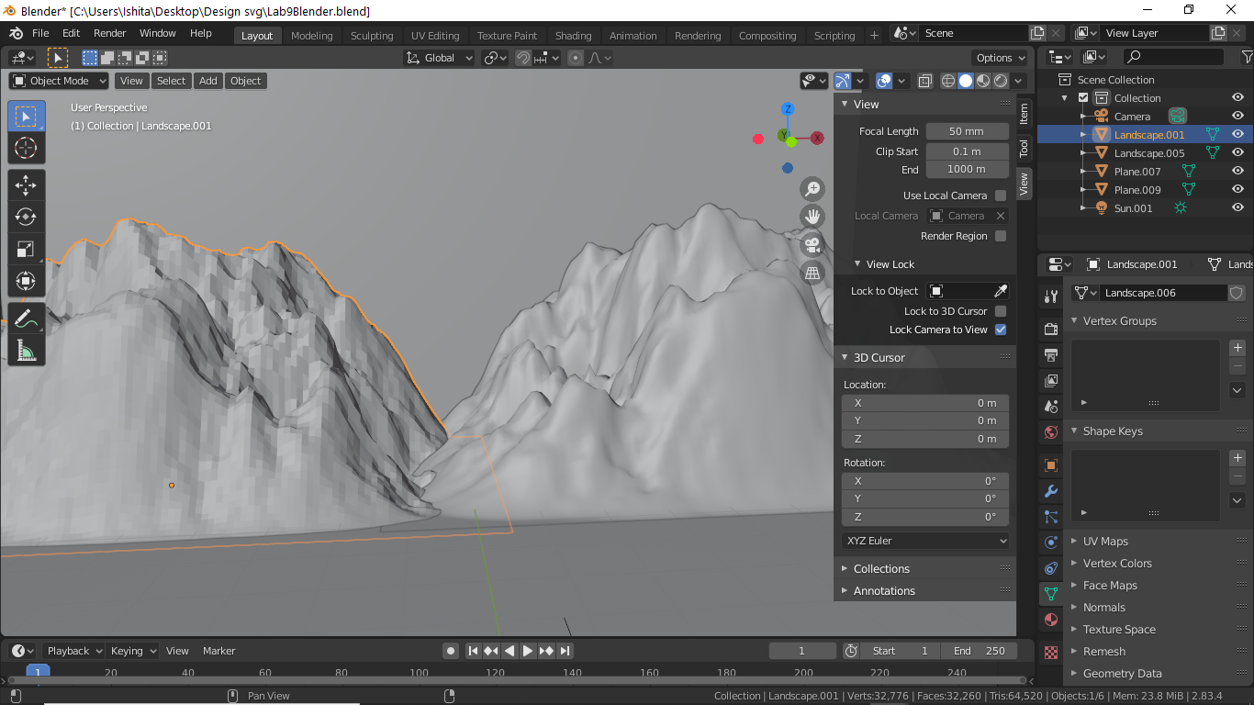

1. Add a plane in the background and in the surface.
2. At last add texture to the mountain. Also add texture of soil and sky to the planes inserted in the previous step.

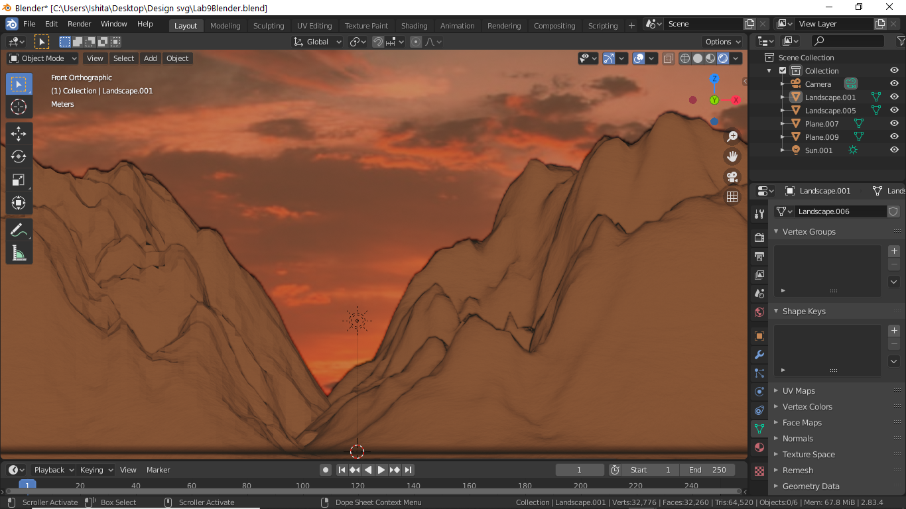

1. Now render the final model.

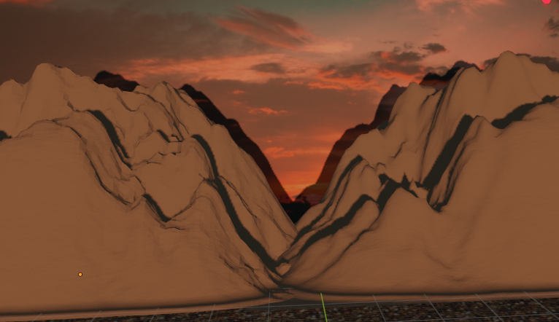

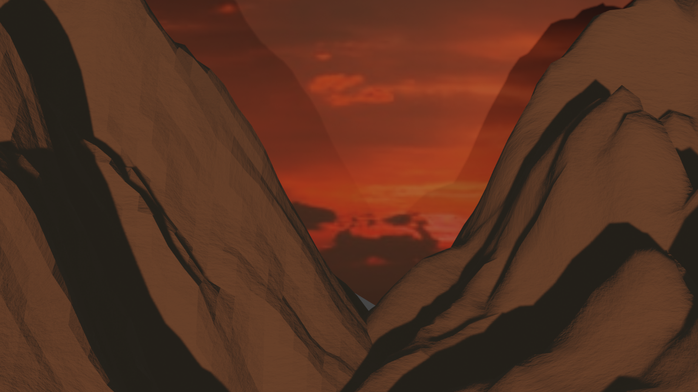

Link for Google Drive: - <https://drive.google.com/drive/folders/1RUgKhpFPlvEgZ-nKeUn2YXHpibvf0PVN?usp=sharing>